Security in Computing Practical 1
Configure Routers for Syslog, NTP, OSPF MD5 and SSH
Practical 1: Configure Routers for Syslog, NTP and SSH operation
Topology:

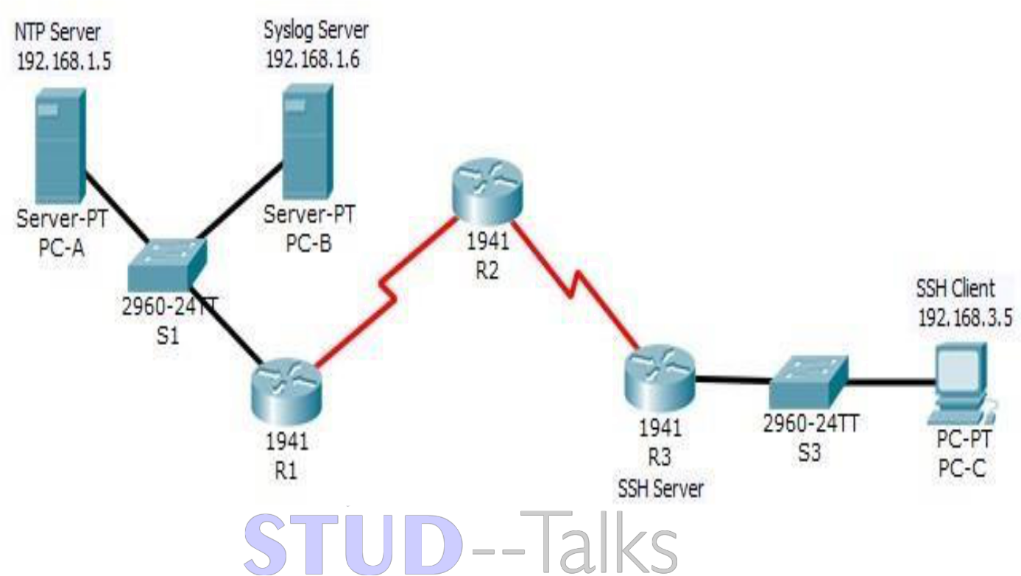

Router R1 Configuration
enable
conf t
hostname R1
enable secret enpa55
line vty 0 4
password vtypa55
login
exit
interface g0/0
ip address 192.168.1.1 255.255.255.0
no shutdown
exit
interface s0/1/0
ip address 10.1.1.1 255.255.255.252
clock rate 64000
no shutdown
exit
router ospf 1
network 192.168.1.0 0.0.0.255 area 0
network 10.1.1.0 0.0.0.3 area 0
area 0 authentication message-digest
exit
interface s0/1/0
ip ospf message-digest-key 1 md5 MD5pa55
exit
ntp server 192.168.1.5
ntp update-calendar
ntp authenticate
ntp trusted-key 1
ntp authentication-key 1 md5 NTPpa55
service timestamps log datetime msec
logging host 192.168.1.6
end
wr

Router R2 Configuration
enable
conf t
hostname R2
enable secret enpa55
line vty 0 4
password vtypa55
login
exit
interface s0/1/0
ip address 10.1.1.2 255.255.255.252
no shutdown
exit
interface s0/1/1
ip address 10.2.2.2 255.255.255.252
no shutdown
exit
router ospf 1
network 10.1.1.0 0.0.0.3 area 0
network 10.2.2.0 0.0.0.3 area 0
area 0 authentication message-digest
exit
interface s0/1/0
ip ospf message-digest-key 1 md5 MD5pa55
exit
interface s0/1/1
ip ospf message-digest-key 1 md5 MD5pa55
exit
ntp server 192.168.1.5
ntp update-calendar
ntp authenticate
ntp trusted-key 1
ntp authentication-key 1 md5 NTPpa55
service timestamps log datetime msec
logging host 192.168.1.6
end
wr

Router R3 Configuration
enable
conf t
hostname R3
enable secret enpa55
ip domain-name ccnasecurity.com
username SSHadmin privilege 15 secret sshpa55
line vty 0 4
login local
transport input ssh
exit
interface g0/0
ip address 192.168.3.1 255.255.255.0
no shutdown
exit
interface s0/1/0
ip address 10.2.2.1 255.255.255.252
no shutdown
exit
router ospf 1
network 192.168.3.0 0.0.0.255 area 0
network 10.2.2.0 0.0.0.3 area 0
area 0 authentication message-digest
exit
interface s0/1/0
ip ospf message-digest-key 1 md5 MD5pa55
exit
ntp server 192.168.1.5
ntp update-calendar
ntp authenticate
ntp trusted-key 1
ntp authentication-key 1 md5 NTPpa55
service timestamps log datetime msec
logging host 192.168.1.6
crypto key zeroize rsa
crypto key generate rsa
1024
ip ssh time-out 90
ip ssh authentication-retries 2
ip ssh version 2
end
wr

Verification Steps
1. Check interfaces:
show ip interface brief
2. Check OSPF neighbors:
show ip ospf neighbor
3. Test connectivity:
ping 192.168.3.1 (from R1)
4. Test SSH:
ssh -l SSHadmin 192.168.3.1
5. Check logs:
show logging
6. Check NTP:
show ntp status

Practical 1: Syslog, NTP, and SSH
- On R1, R2, and R3:
  - show ntp status: To verify if the clock is synchronized with the NTP server (192.168.1.5).
  - show ntp associations: To see the status of the connection to the NTP server.
  - show logging: To confirm that system messages are being time-stamped and sent to the Syslog host (192.168.1.6).
- On R1:
  - ping 192.168.3.1: To test end-to-end connectivity to R3 via OSPF.
- From a PC or R1:
  - ssh -l SSHadmin 192.168.3.1: To verify SSH access to R3 using the configured username.

Practical 1: Syslog, NTP, and SSH
On Routers (R1, R2, R3)
- Verify OSPF MD5: Run show ip ospf interface. Look for "Message-digest Authentication Enabled" and "Youngest key ID is 1".
- Verify NTP Client: Run show ntp status to check synchronization with the server (192.168.1.5).
- Verify Hardware Clock: Run show clock to ensure the time has updated via NTP.
- Verify Logging: Run show logging to confirm that the Syslog host is configured.
- Verify SSH (on R3): Run show ip ssh to confirm Version 2, Timeout 90, and Retries 2.
On PCs (PC-A, PC-B, PC-C)
- Connectivity: From PC-A, run ping 192.168.3.5 (PC-C).
- SSH Access: From PC-C, run ssh -l SSHadmin 192.168.3.1 and enter password sshpa55.
- Telnet Block: From PC-C, run telnet 192.168.3.1 (should fail).

